

**Project Management Plan for Travel advisor web-based app**

V 1.7



May 17, 2022

ITI, qa TEAM

Prepared by: Saad Hamdy

Table of Contents

**Project Management Plan for Travel advisor web based app** 0

Prepared by: Saad Hamdy 0

1. Introduction 3

1.1 Purpose of project management plan 3

1.2 Summary of project charter 3

I. Introduction 3

II. Business need 3

III. Unique Solution 3

IV. Timeline 4

V. Team 4

VI. Conclusion 4

1.3 Assumptions and Constraints 4

I. Assumptions: 4

II. Constraints: 4

1.4 Scope Management 4

1.5 Work Breakdown Structure 5

I. Diagram 5

II. Responsibilities 5

2. Schedule / Time Management 5

3. Quality management 5

4. Configuration Management 5

4.1 Tracing and control 5

4.2 Folder structure 6

4.3 Guidelines for using the CM Tool 7

5. Communication Management 7

6. Risk Management 7

6.1 Risk log 7

7. Issue Management 8

7.1 Escalations 8

APPENDEIX A 8

**Revision History**

|  |  |  |  |
| --- | --- | --- | --- |
| **Name** | **Date** | **Reason For Changes** | **Version** |
| Aya | 15/4/2022 | No issues found | 1.0 |
| Saad | 25/4/2022 | Adding required edits in escalation | 1.1 |
| Saad | 29/4/2022 | Adding naming convention | 1.2 |
| Nada | 6/5/2022 | Adding Revision History | 1.3 |
| Ashry | 10/5/2022 | Updating Escalation | 1.4 |
| Osama | 11/5/2022 | Updating file structure | 1.5 |
| Osama | 17/5/2022 | Updating guidelines for using the CM Tool | 1.6 |
| Osama | 26/5/2022 | Updating naming convention to bug report and testcases | 1.7 |

# 

# Introduction

## Purpose of project management plan

The intended audience of the Travel advisor PMP is all project stakeholders including the project sponsor, senior leadership and the project team.

Maintaining the ease of communication between customer and Travel Advisor Company through building a website which will help us to establish an accurate more beneficial routine of work to meet the end of scope, time and cost goals required to achieve.

One of the most touted benefits of travel advisor website is providing peace of mind to travelers allowing them to view updated tours and destination of any country they want, also taking in count feedback from previous customers.

Part of our goals is to provide customer with easy access to booking and viewing trips without the need to physically be in the company.

## Summary of project charter

### Introduction

Our vision: Be the world’s most trusted and innovative travel Management Company.

Our mission: To inspire and enable people to confidently explore, experience and share our world

### Business need

Providing easier access to booking systems and being available 24/7, providing reliable feedback from previous travelers.

### Unique Solution

The customer need for an easier way to communicate with the company and booking the trips based on the reviews of the other customers experience in this se saw an opportunity for the company to deliver the value needed to the customer with a little margin of profits.

Our website try to be different as the customer actually find a user friendly interface with the highest performance possible to satisfy the customer.

### Timeline

We plan to provide four milestones for the project and define the project as ready for publishing in 5 weeks of working as it needs approximately 375 hours.

### Team

Our team consists of 5 members as follow:

1. Saad Hamdy: project & configuration manager
2. Ahmed Medhat: Developer ,Designer and Tester
3. Aya Ahmed: Developer and Tester
4. Muhammed Ashry: Developer and Tester
5. Nada Abdelrehem: Developer and Tester

### Conclusion

This project will provide the needed luxury for user and provide the customer with the needed functionality to achieve the highest market value (profit).

## Assumptions and Constraints

### Assumptions:

* We are developing using c#.
* Browsers: Chrome, Firefox and Edge
* Operating System: Win 7,XP, Vista, 8, 10, 11.
* Recommended Conf.: 256mb RAM or higher, 10mb Disk space.
* Screen Resolution: 1024x768.

### Constraints:

* Web-based system / PC based
* Unique user id
* Admin features needed: (Add new destination/tour, add user, set budget)

## Scope Management

Scope management plan is discussed in two file the scope statement which define the scope and scope management plan which is describing how to manage the scope these files are both in the Concept folder under the names (Project Statemetn.docs and Scope Management Plan.docs)

## Work Breakdown Structure

### Diagram

There is a description for this diagram in WBS_dictionary.xlsx which is in requirement folder in definition folder.

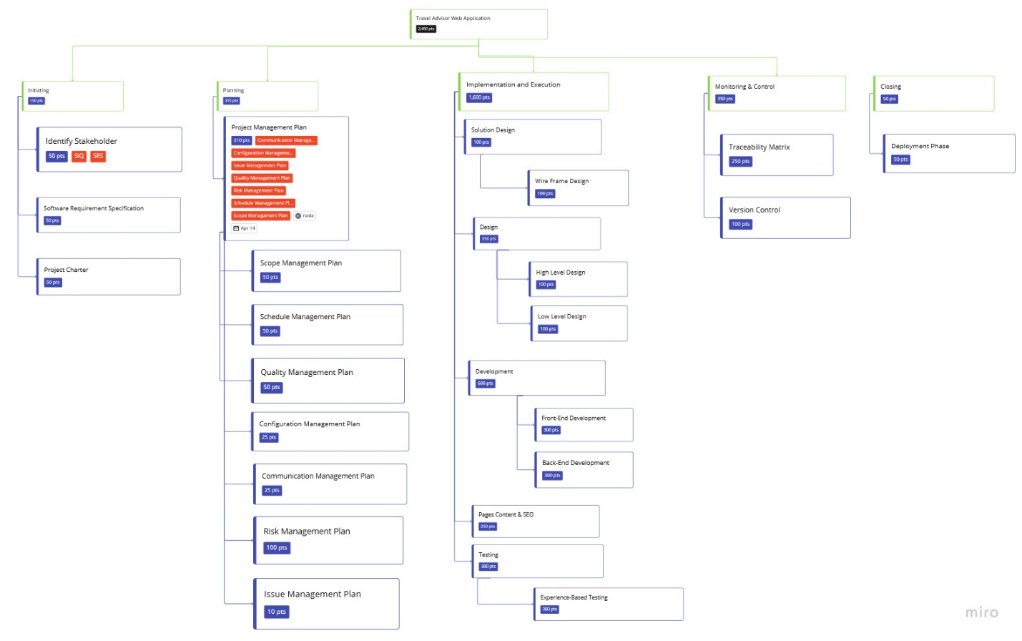

Figure -WBS

### Responsibilities

This is described under the file of RCIA.xlsx in the Concept folder.

# Schedule / Time Management

Schedule management plan is set in external file which is set in Concept folder you will find t under the name of Schedule Management Plan.docx

# Quality management

The Project Quality Management Plan documents the necessary information required to effectively manage project quality from project planning to delivery. It defines a project’s quality policies, procedures, criteria for and areas of application, and roles, responsibilities and authorities.

For the details of the Quality management plan please check the Quality management plan attached to the project.

# Configuration Management

## Tracing and control

We will track all our documents, code, testing, monitor & control phases through the software life cycle (SDLC).

We tailored our Configuration Management tool to use Git and GitHub instead of Folder structure

These folders contain:

* Concept : contains the main plans of our project
* Definition :
  1. Design: which will contain the main design of the project either high level or low level
  2. Requirements: which contains the SRS and WBS and other requirements files.
* Development:
  1. Front-end: which will contain the layout design to our project.
  2. Back-end: which will contain the database & the backend project.
* Monitor and Control: this folder contains the plans of the risk and Issue management plans and Logs and will contain the change request by the customer.
* Testing:

1. Specs: which will contain the test cases.
2. Reports: the reports resulting from testing.

## Guidelines for using the CM Tool

There are two branches:

The first one is for the baseline. (Master)

The other one is for the internal changes between the releases (dev_branch).

Pull requests are required.

* Tags will be used to distinguish between baselines.

Tags must be in this format for baselines on the master (Day-Month-Year_Inter/Release_no of release) ex:160422-Release-01

* If there were any updates in the baseline version (in the same tag version) the format will be (Day-Month-Year_Inter/Release_no of release (Major number) _update-no (Minor Number) ex:160422_Release_01_01

## Naming convention

**Files:**

All the files in the project should be named after the document it is describing examples:

1. User_class.
2. Project management plan.

Or it can user abbreviations of the document it is describing:

1. SRS (System Requirements Specifications).

**Requirements:**

Should start with REQ-Number of requirement- Model it’s following example:

1. REQ-01-Signup
2. REQ-10-Add_User

**Design files:**

Should start with the type of the design_the name of the module or if it’s a high-level design should just be written as the name of the diagram.

1. Layout_Home
2. ERD

**Code files:**

Should start with the name of the Code module, if there is a function inside a module which describes the requirement you just mention the function name.

1. SignUp_aspx
2. SignUp_controller

**Test Cases:**

Test cases ID must start with the shortage of test case (TC) followed by module name and end with test case number and it must contain (ID, Title, Description, Pre condition, Steps, Expected result, actual result, Status, Author, Date).

1. TC_AddTour_001

**Bug Report:**

Bug Report ID must start with module name and end with bug report number it must contain (ID, Title, Description, Pre condition, Steps, Expected result, actual result, Status, Priority, Severity, Author, Date).

# Communication Management

|  |  |  |  |
| --- | --- | --- | --- |
| **Communication Goal** | **Communication Tool** | **Audience** | **Frequency** |
| Daily Stand UP | Online Meeting | All team | Daily |
| Project Review | Physical Meeting | Project Team | Weekly |
| Customer Collaboration | Formal Email | Customer – Project Manager | when needed |
| Delivery meeting | Formal presentation | Project Team – Customer | At delivery time |

# Risk Management

The risk management plan is the guideline of how to deal with the risks concerning the project and it’s available on the Monitoring and control folder as Risk management plan.docs.

## Risk log

This file is used to describe the risks identified by the team and how to deal with them.

It is available in Monitoring and control folder under the name Risk log.xlsx.

# Change Control Management

* Change Management Plan
* Change Request
* Change Management Log

# Issue Management

The Issues management plan is the guideline of how to deal with the Issues concerning the project and it’s available on the Monitoring and control folder as Issue management and escalation docs.

## Escalations

The Escalation is the guideline of how to deal with the escalations concerning the project and it’s available on the Monitoring and control folder as Issue management and escalation docs.

# APPENDEIX A

|  |  |
| --- | --- |
| **Document Name** | **Location** |
| Project Charter | Concept\Project Charter.docx |
| Scope management | Concept\ Scope Management Plan .docx |
| Scope Statement | Concept\ Scope Statement.docx |
| Schedule | Concept\Schedule Management Plan.docx |
| RCIA | Concept\ RCIA.xlsx |
| Work breakdown structure | Definition\Requirements\WBS_Dictionary.xlsx |
| Quality Management | Monitor and Control\Quality Management Plan.docx |
| Risk Management | Monitor and Control\Risk Management Plan.docx |
| Risk Log | Monitor and Control\Risk Management Log.xls |
| Issue Management | Monitor and Control\Issue Management Plan.docx |
| Change Management plan | Monitor and Control\ Change_Management_Plan.doc |
| Change Request | Monitor and Control\ Change-Request  .docx |
| Change Management Log | Monitor and Control\ Change_Management_Log.xls |